Deep Learning Summary

* Deep learning architectures combine a sophisticated automatic feature extraction phase with a supervised learning phase
* The feature extraction phase uses a hierarchy of multiple feature extraction layers
* Starting from primitive, low-level features in the initial layer, each feature layer’s output provides the input features to the next higher feature layer
* All features are used in the final supervised learning model

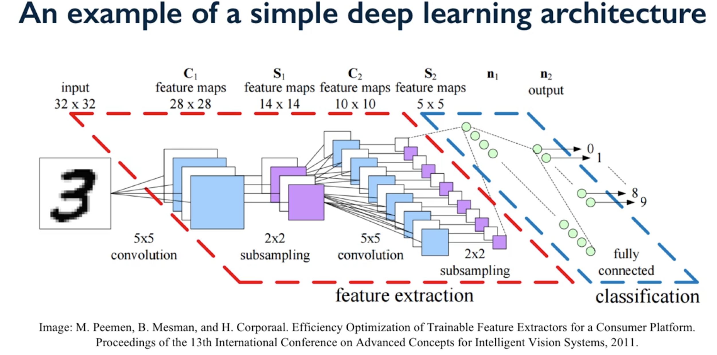

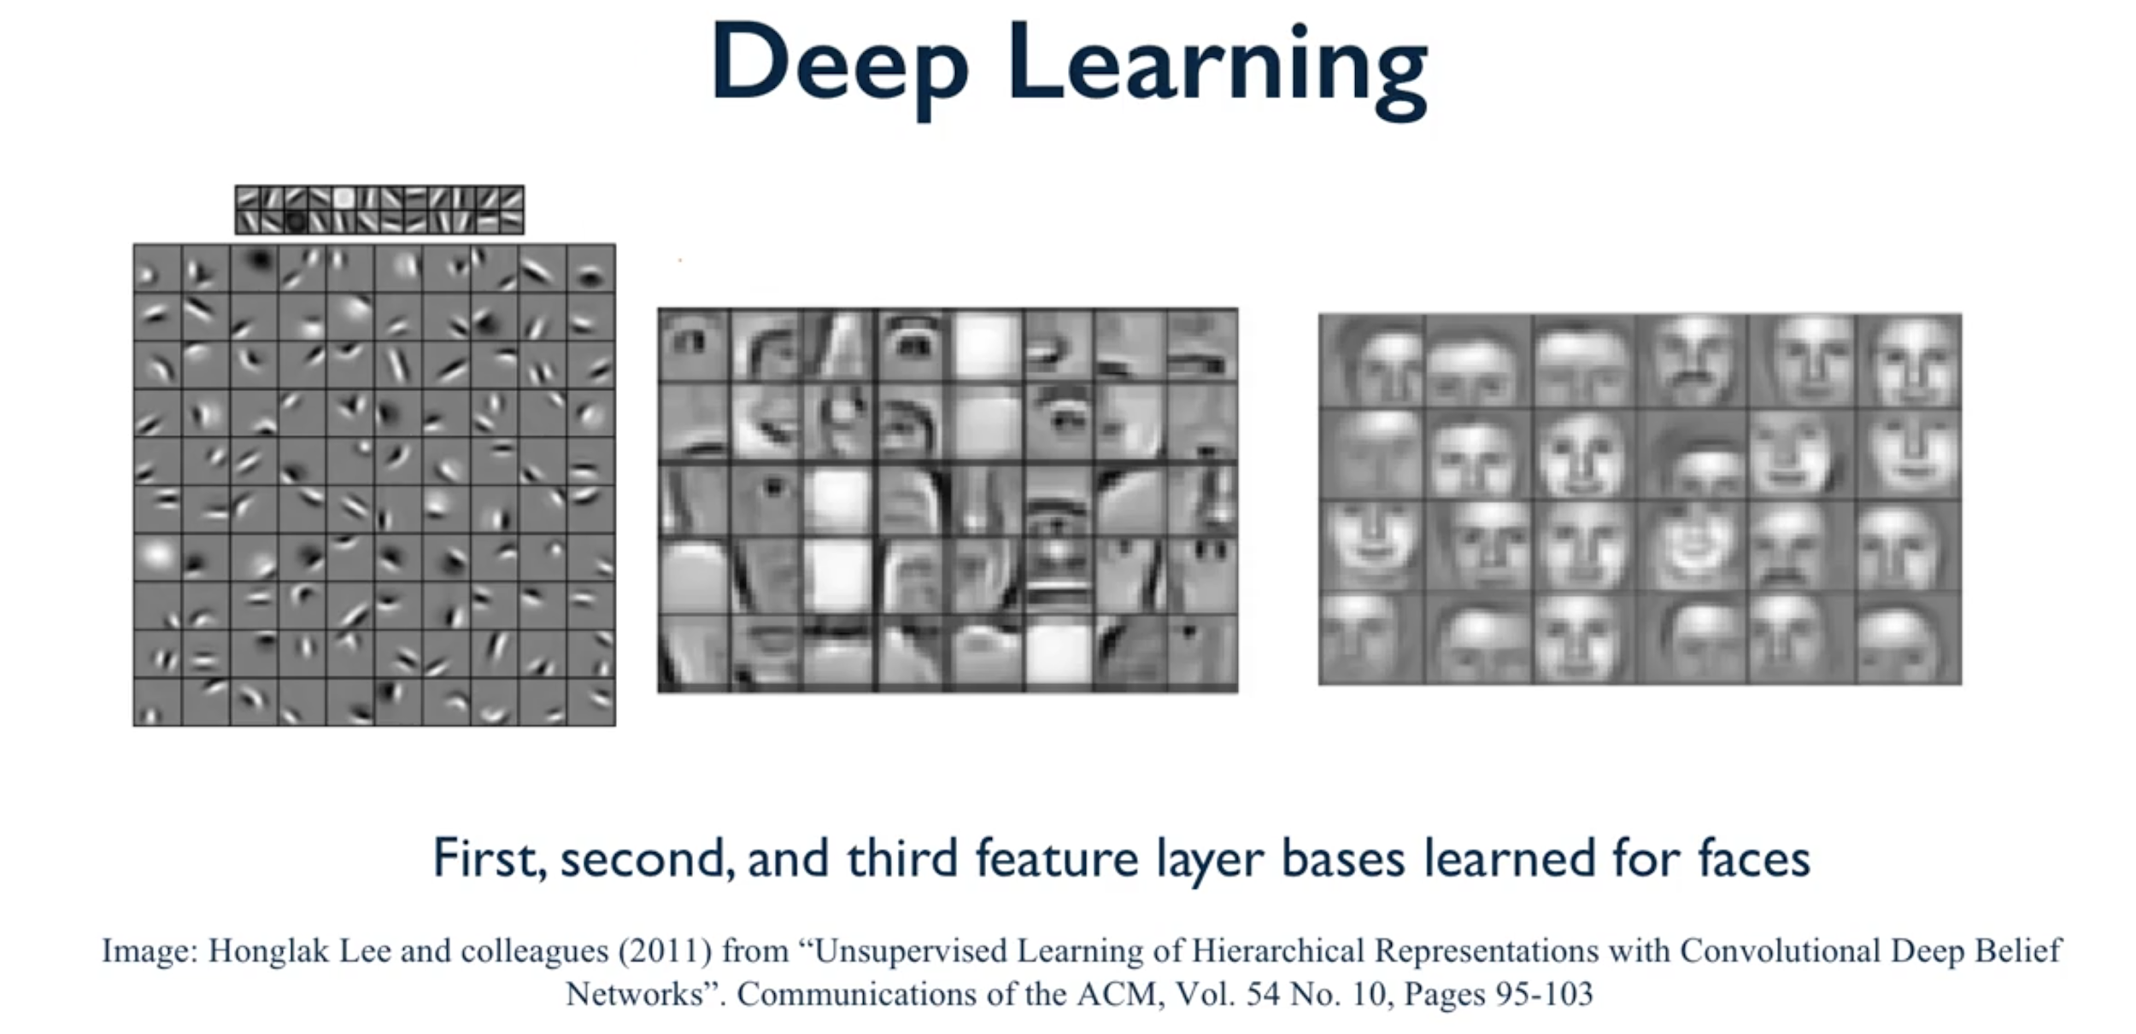

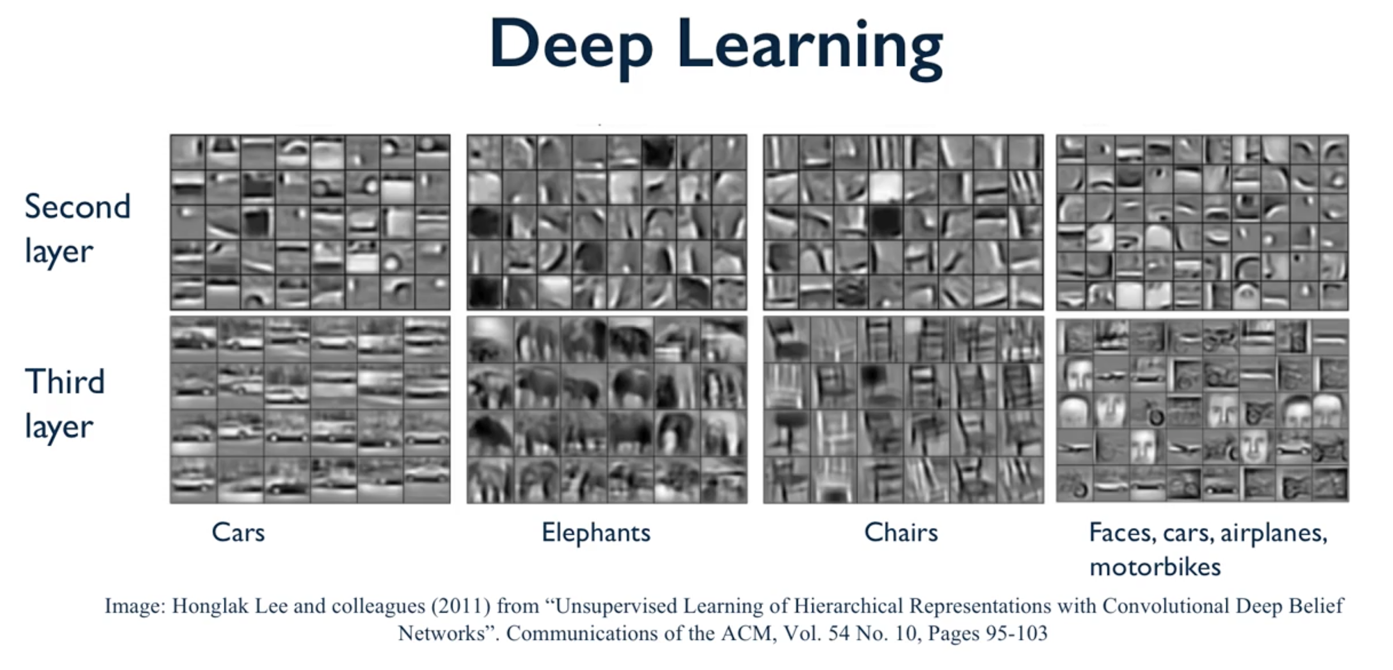

Pros and Cons of Deep Learning

* Pros:
  + Powerful: deep learning has achieved significant gains over other machine learning approaches on many difficult learning tasks, leading to state-of-the-art performance across many different domains
  + Does effectively automatic feature extraction, reducing the need for guesswork and heuristics on this key problem
  + Current software provides flexible architectures that can be adapted for new domains fairly easily
* Cons:
  + Can require huge amounts of training data
  + Can require huge amounts of computing power
  + Architectures can be complex and often must be highly tailored to a specific application
  + The resulting models may not be easily interpretable

Introduction: Unsupervised Learning

* Unsupervised learning involves tasks that operate on datasets without labeled responses or target values
* Instead, the goal is to capture interesting structure or information
* Applications of unsupervised learning:
  + Visualize structure of a complex dataset
  + Density estimation to predict probabilities of events
  + Compress and summarize the data
  + Extract features for supervised learning
  + Discover important clusters or outliers

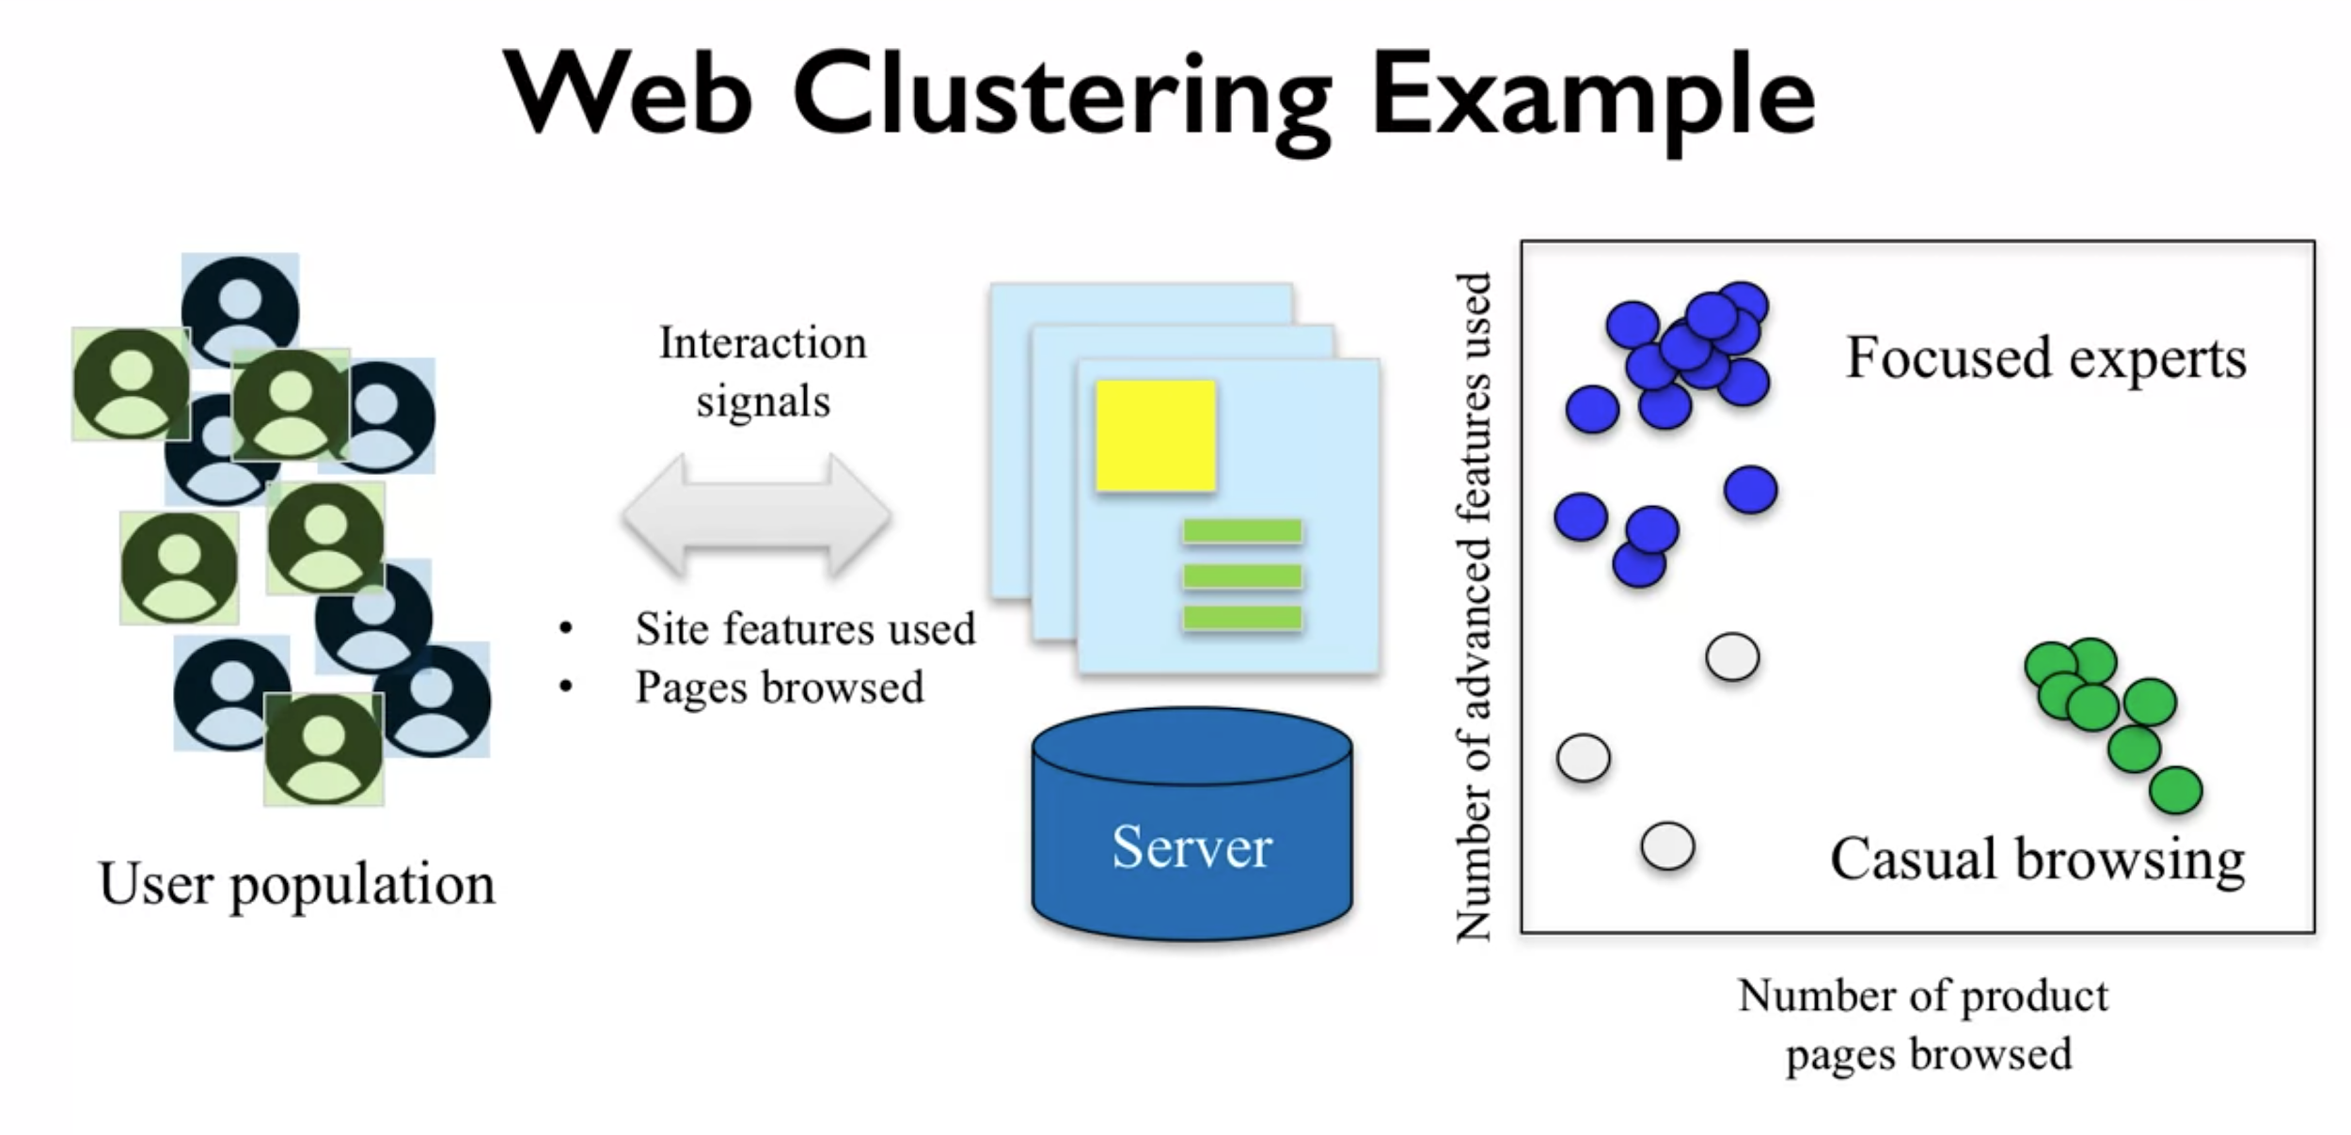

* Useful for business to group users of the site according to their shopping behavior with unsupervised learning

Two major types of unsupervised learning methods

* Transformations
  + Processes that extract or compute information
* Clustering
  + Find groups in the data
  + Assign every point in the dataset to one of the groups

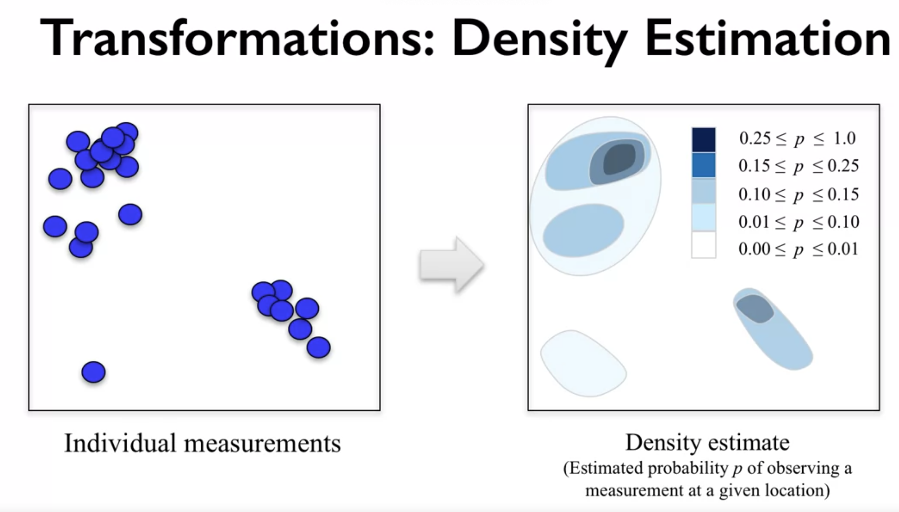

* One method called density estimation is used when you have a set of measurements scattered throughout an area.
* And you want to create what you can think of as a smooth version over the whole area that gives a general estimate for how likely it would be to observe a particular measurement in some area of that space.

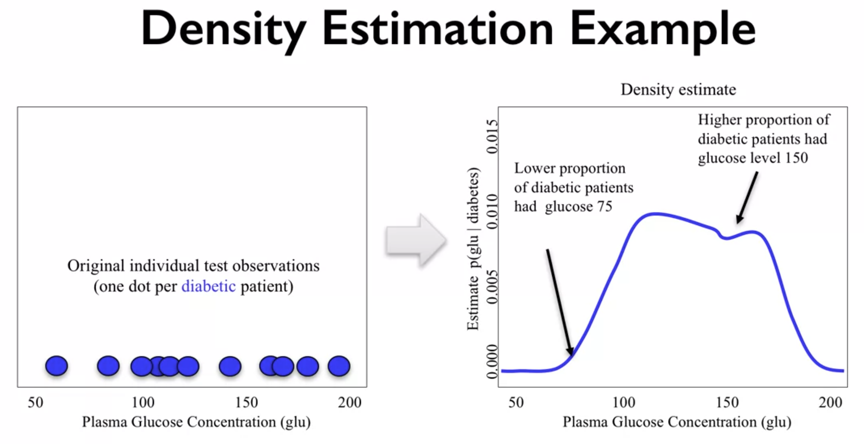

* For example, in a medical application related to diagnosing diabetes, density estimation with one variable might be used to estimate the distribution of a specific test score.
* The plasma glucose concentration number from a blood test for people who have a particular form of diabetes.
* With this density estimate we can estimate the probability that anyone with that medical condition has a particular glucose score. Even if that specific score wasn't seen in the original dataset.

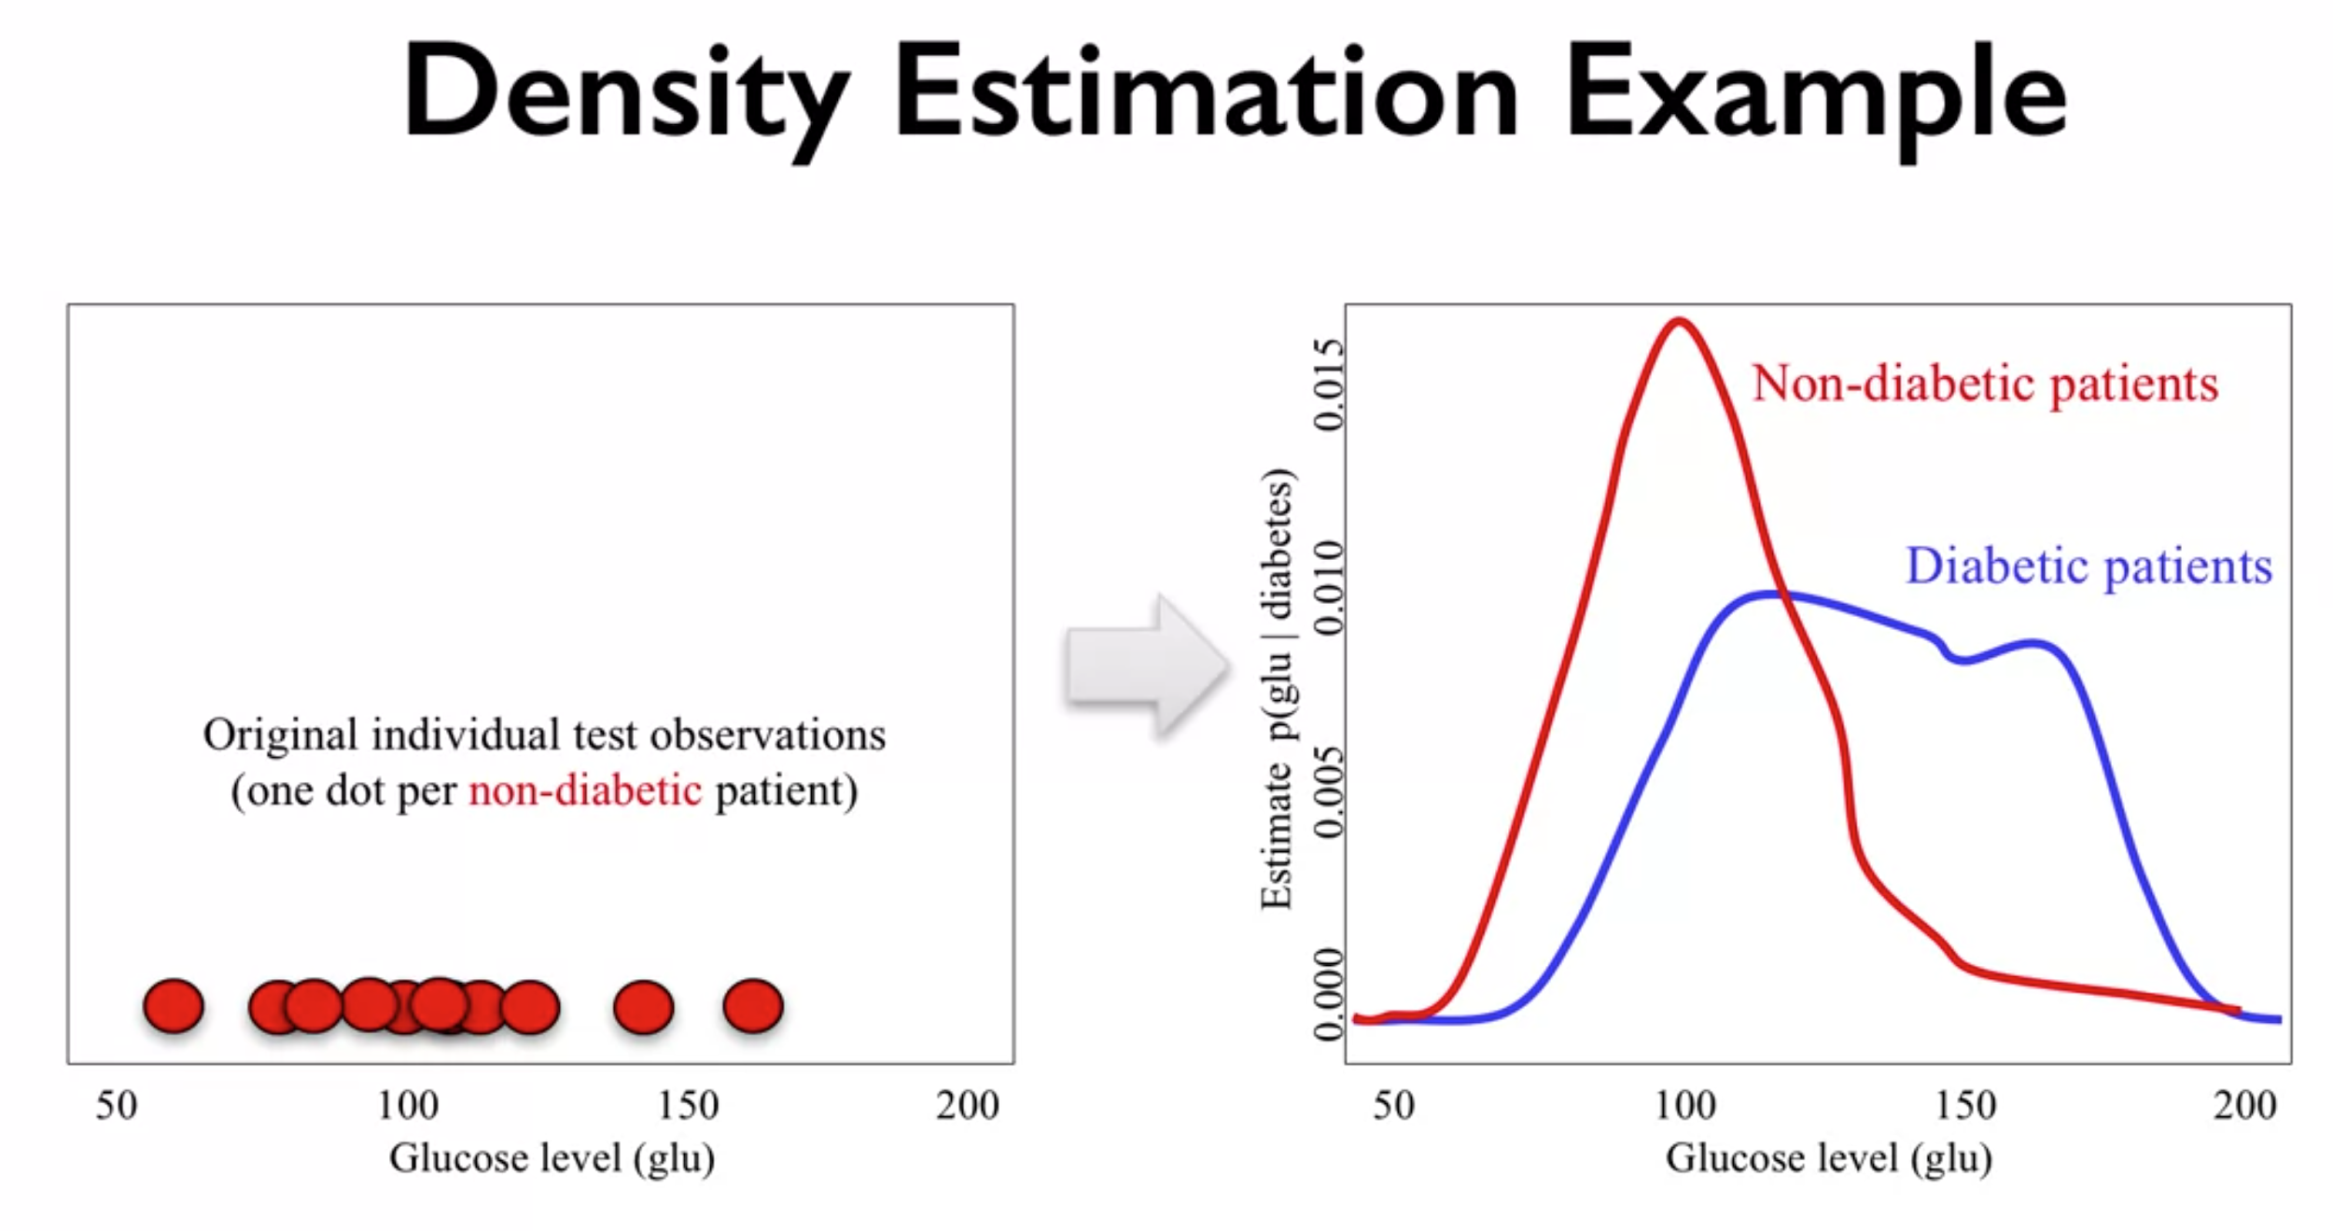

* We could then compare this to the range of glucose levels for people who do not have that condition, which is shown by the red line here.

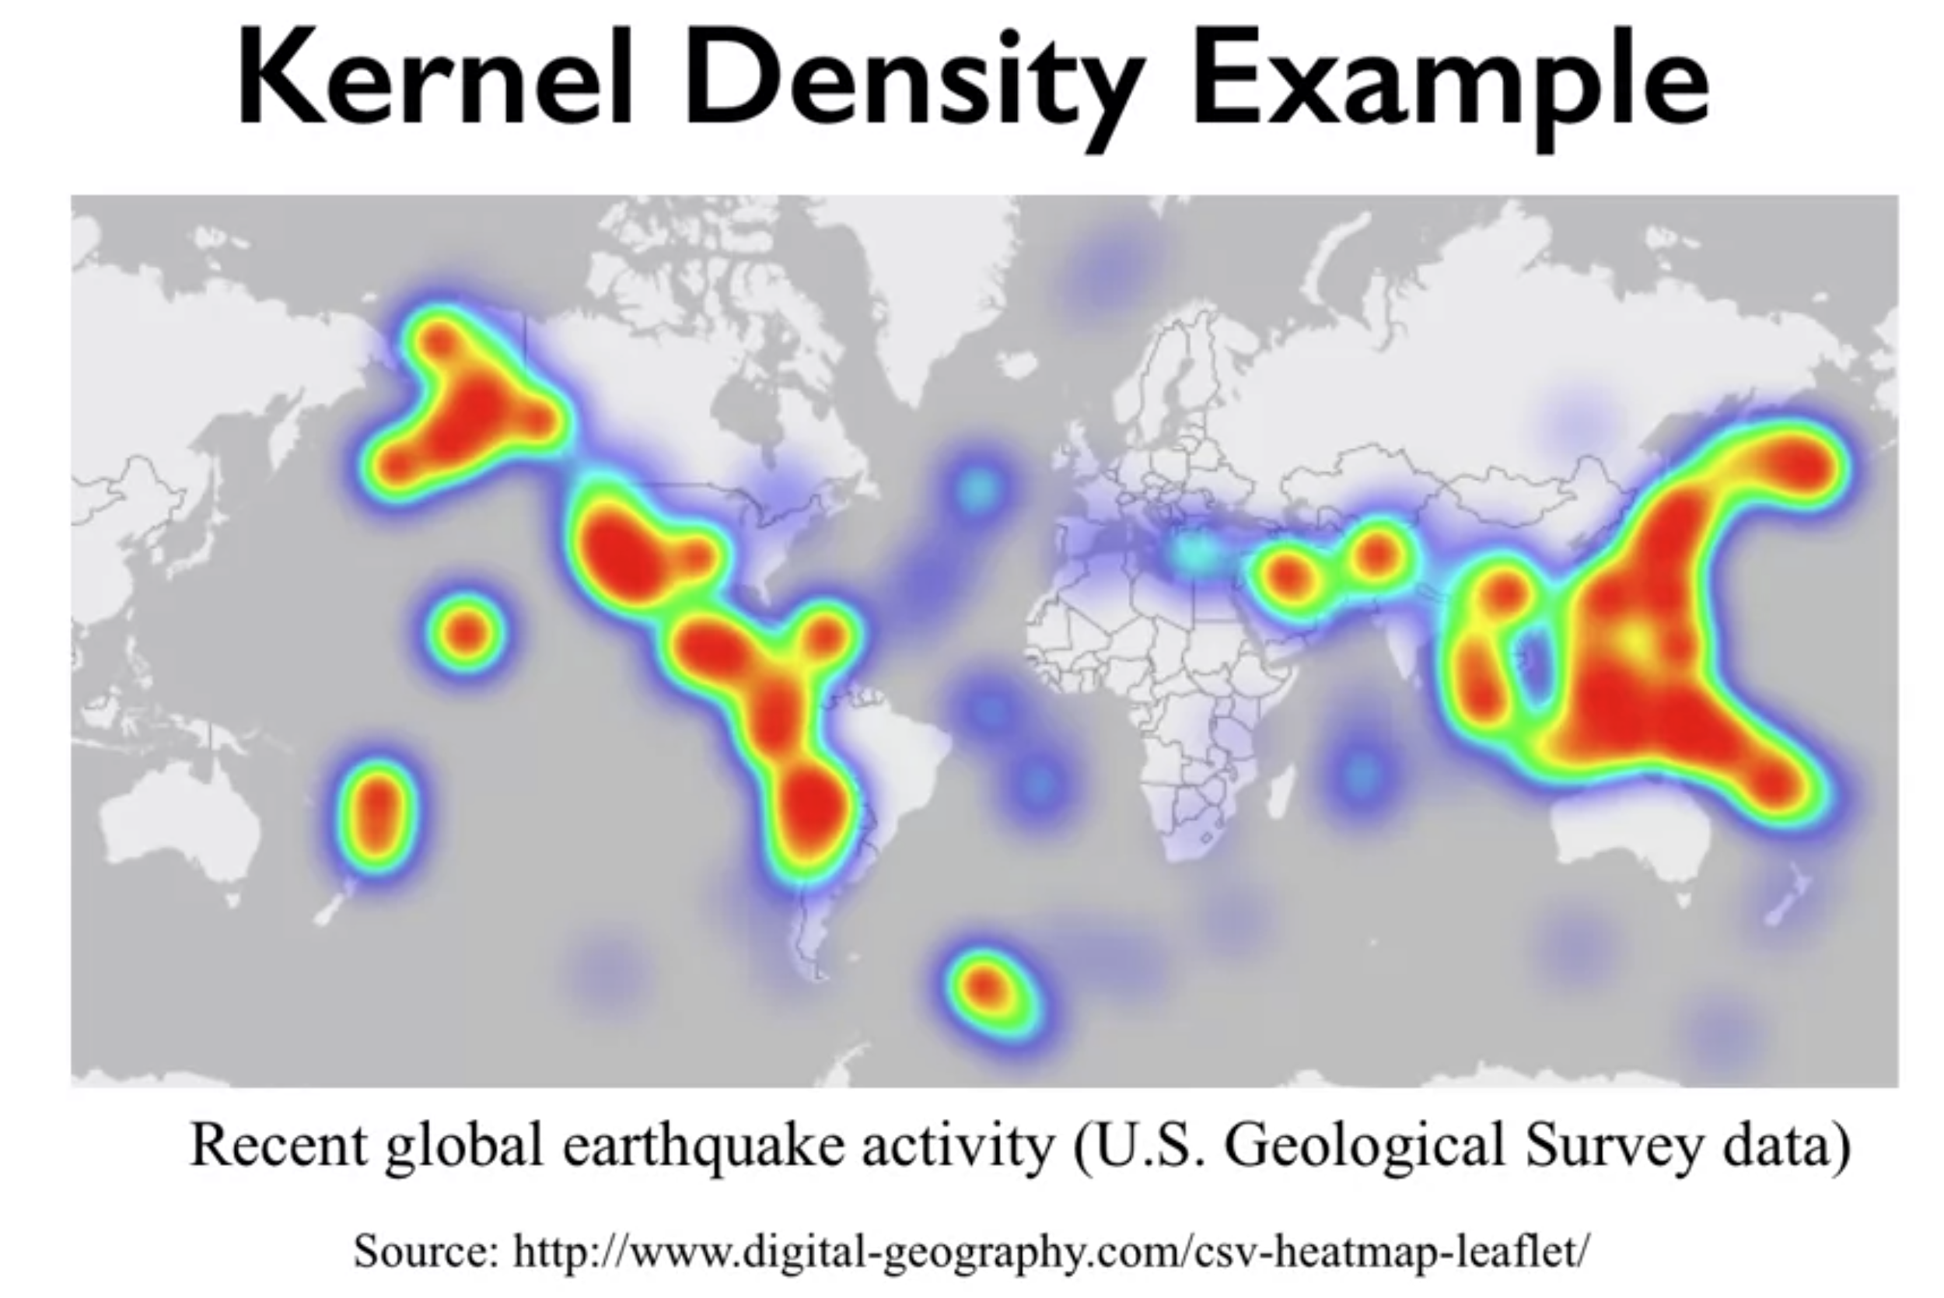

* density estimation calculates a continuous probability density over the feature space, given a set of discrete samples in that feature space.
* you can use the kernel density class in the sklearn.neighbors module to perform one widely used form of density estimation called kernel density estimation.

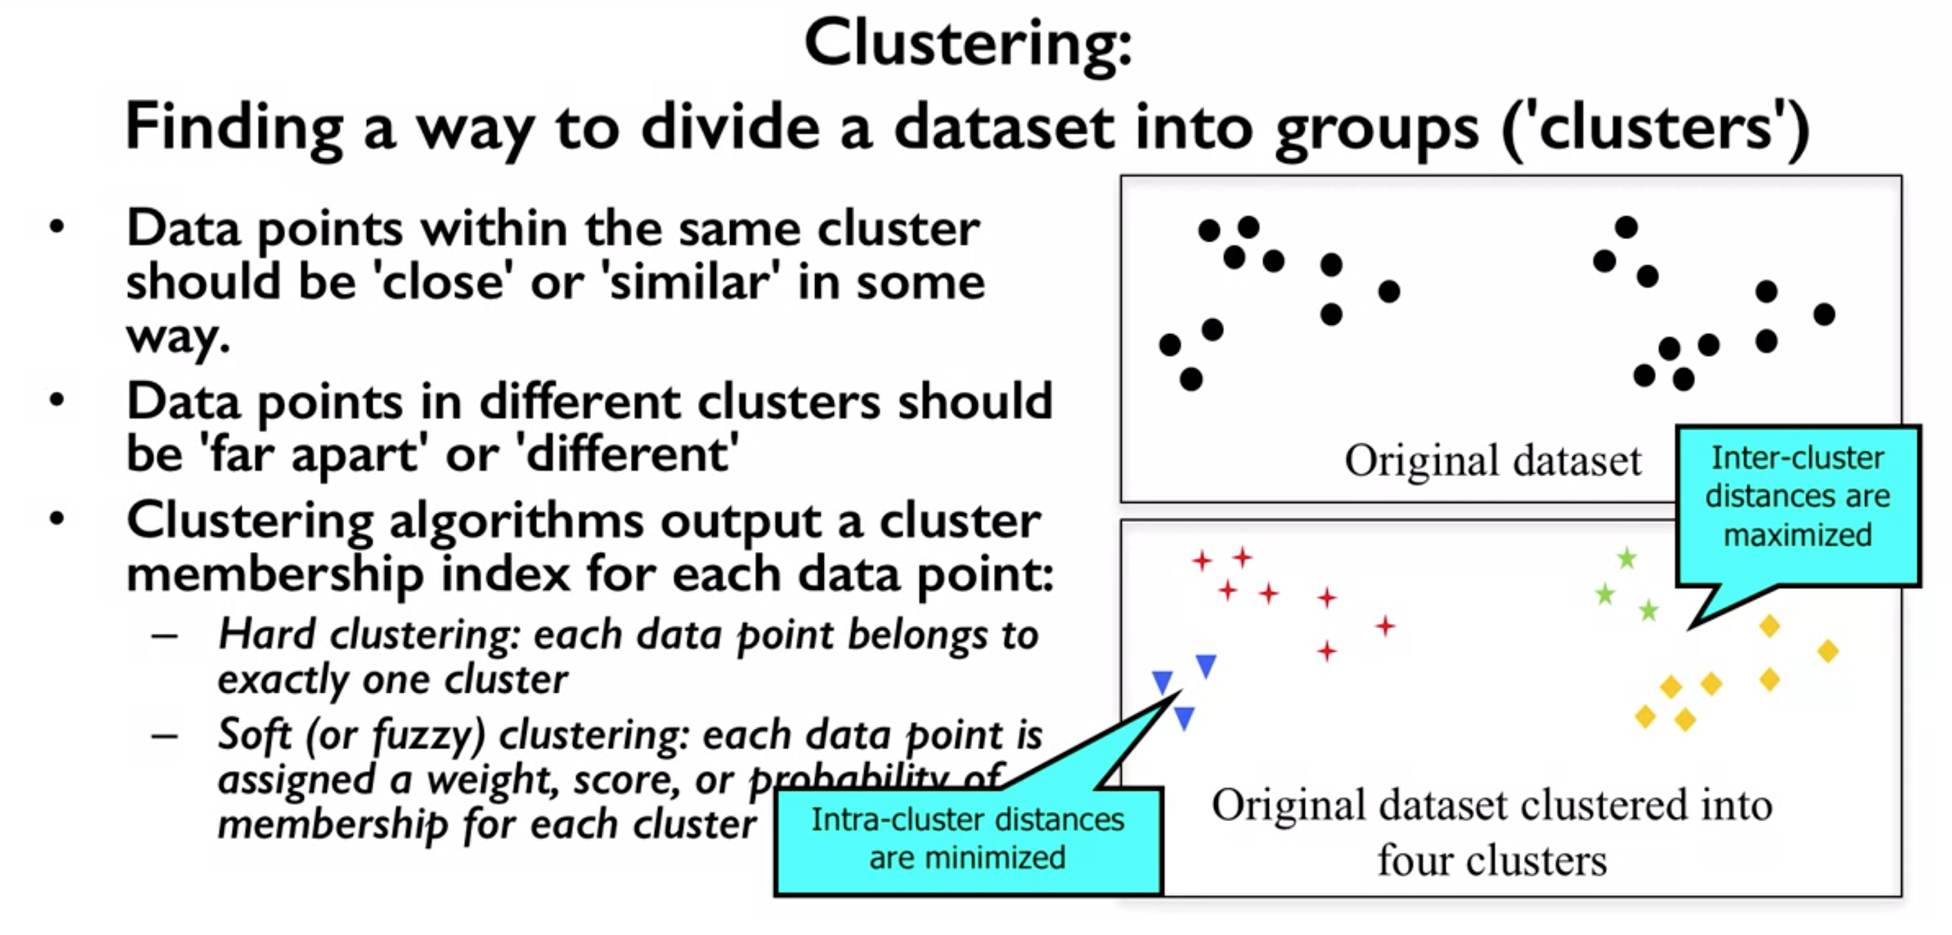

* If new data points were being added over time, some clustering algorithms could also predict which cluster a new data instance should be assigned to. Similar to classification, but without being able to train the clustering model using label examples in advanced.

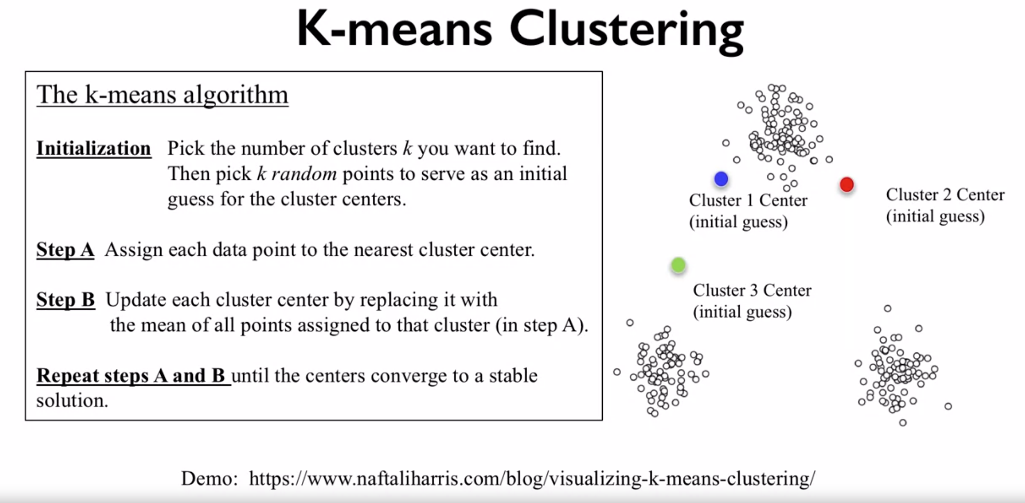

* You need to specify the value of k ahead of time, which is one of the drawbacks of k-means.
* In the first step, given the locations of existing cluster centers, it assigns each data point to a cluster center based on its distance from the center.
* Then in the second step, it adjusts the locations of each cluster center. It does this by setting the new cluster center to the mean of the positions of all the data points in that cluster.

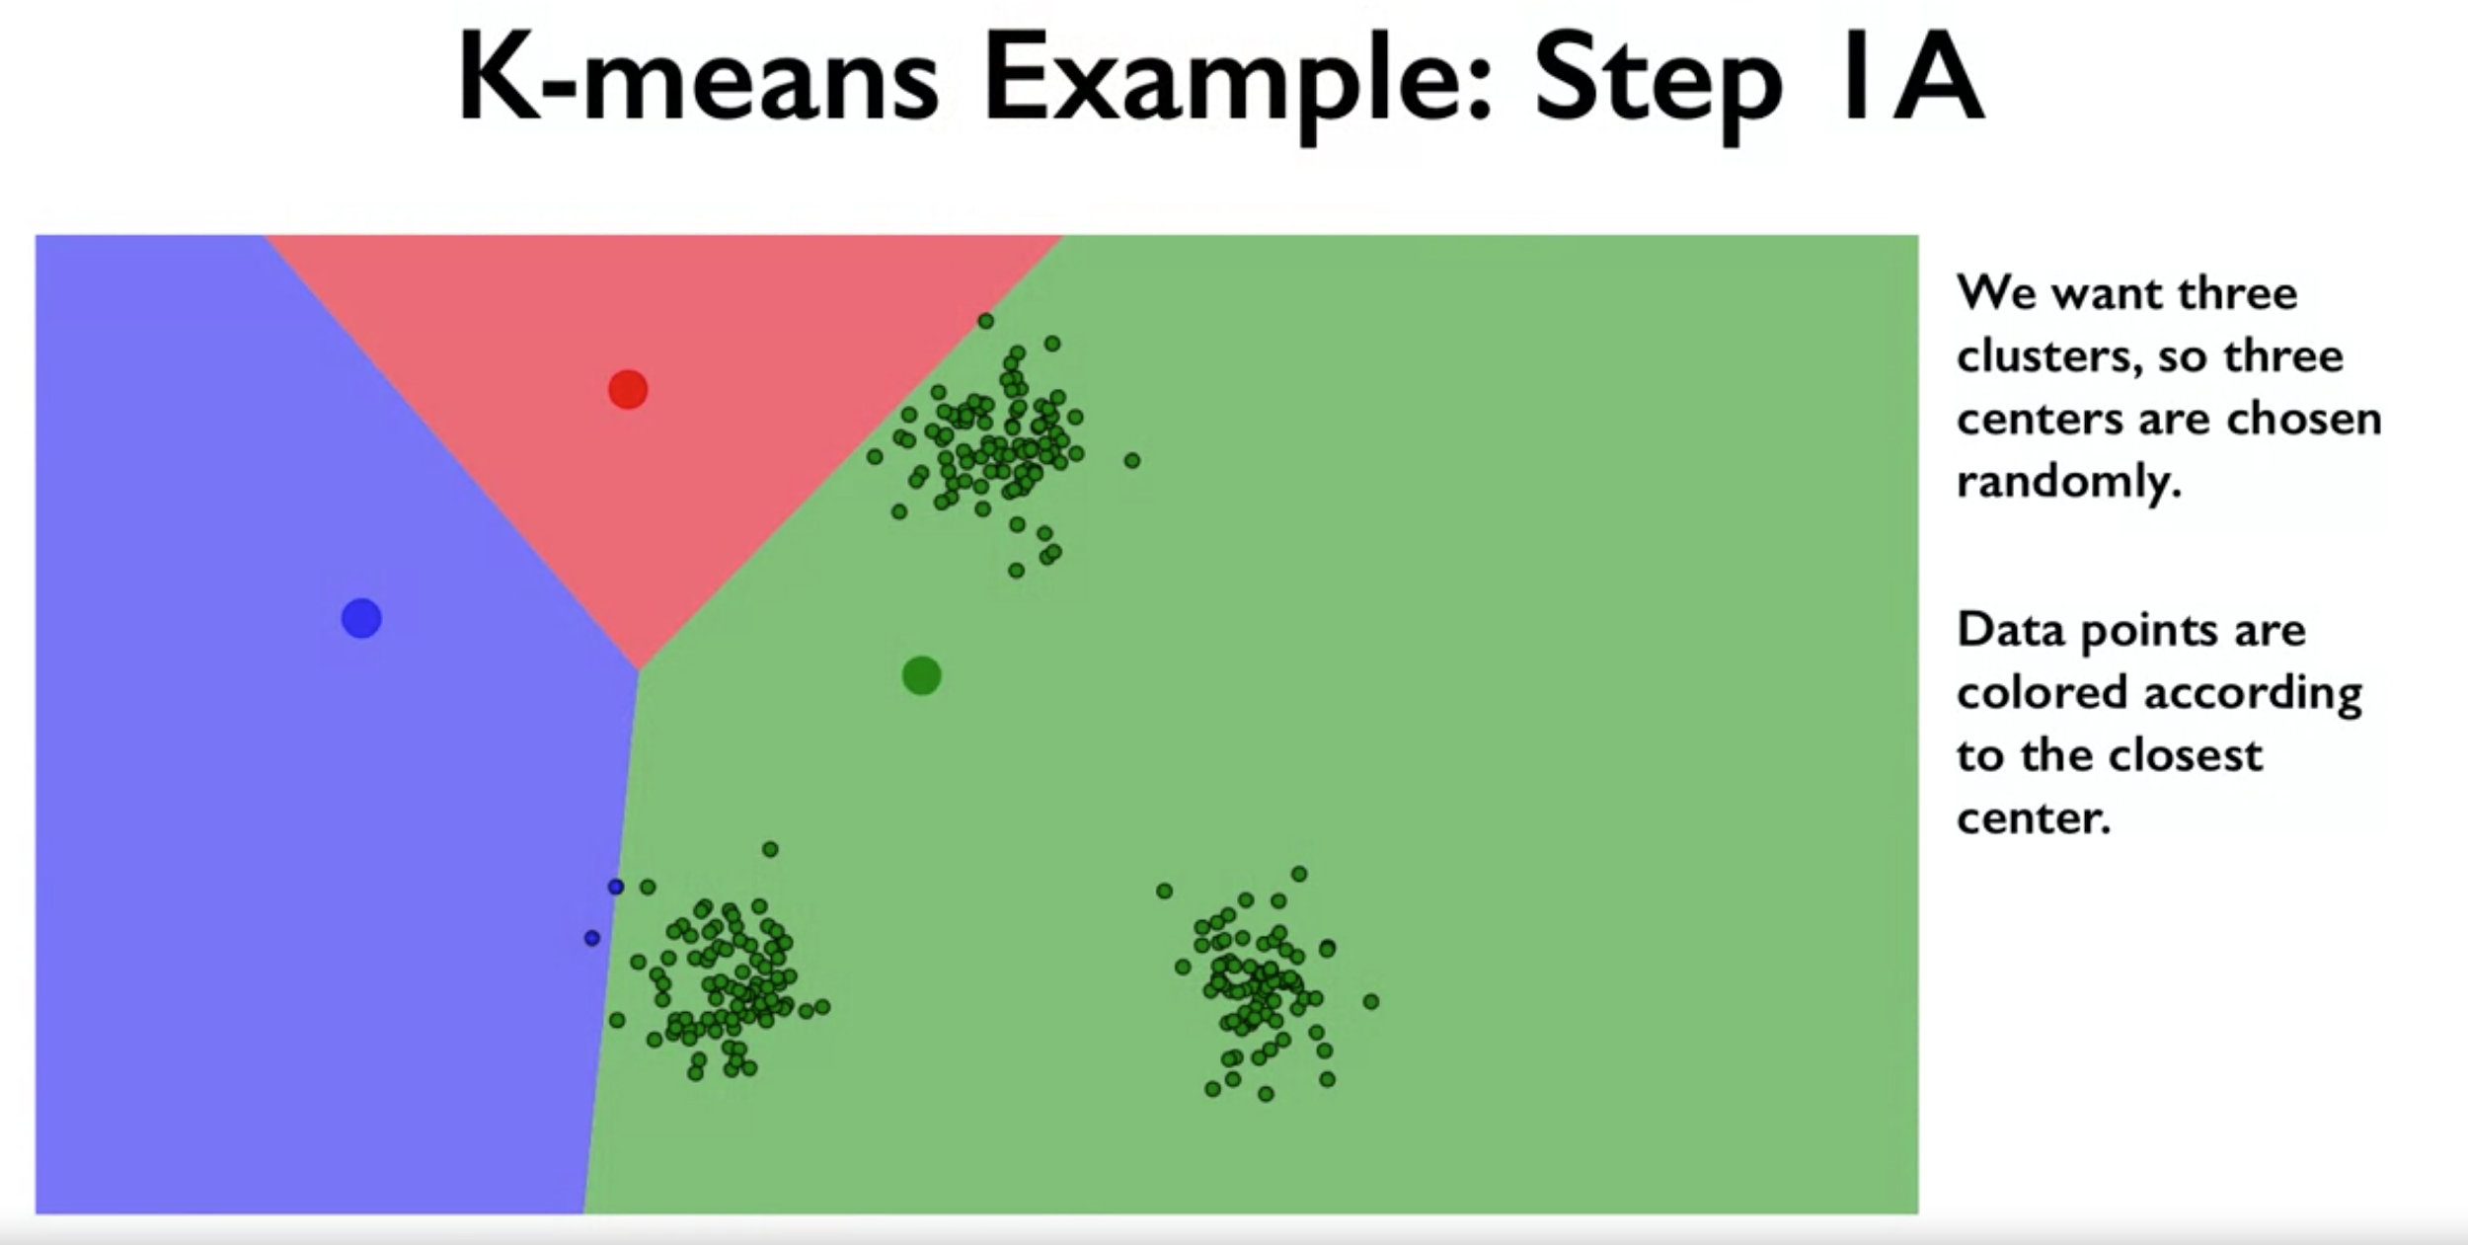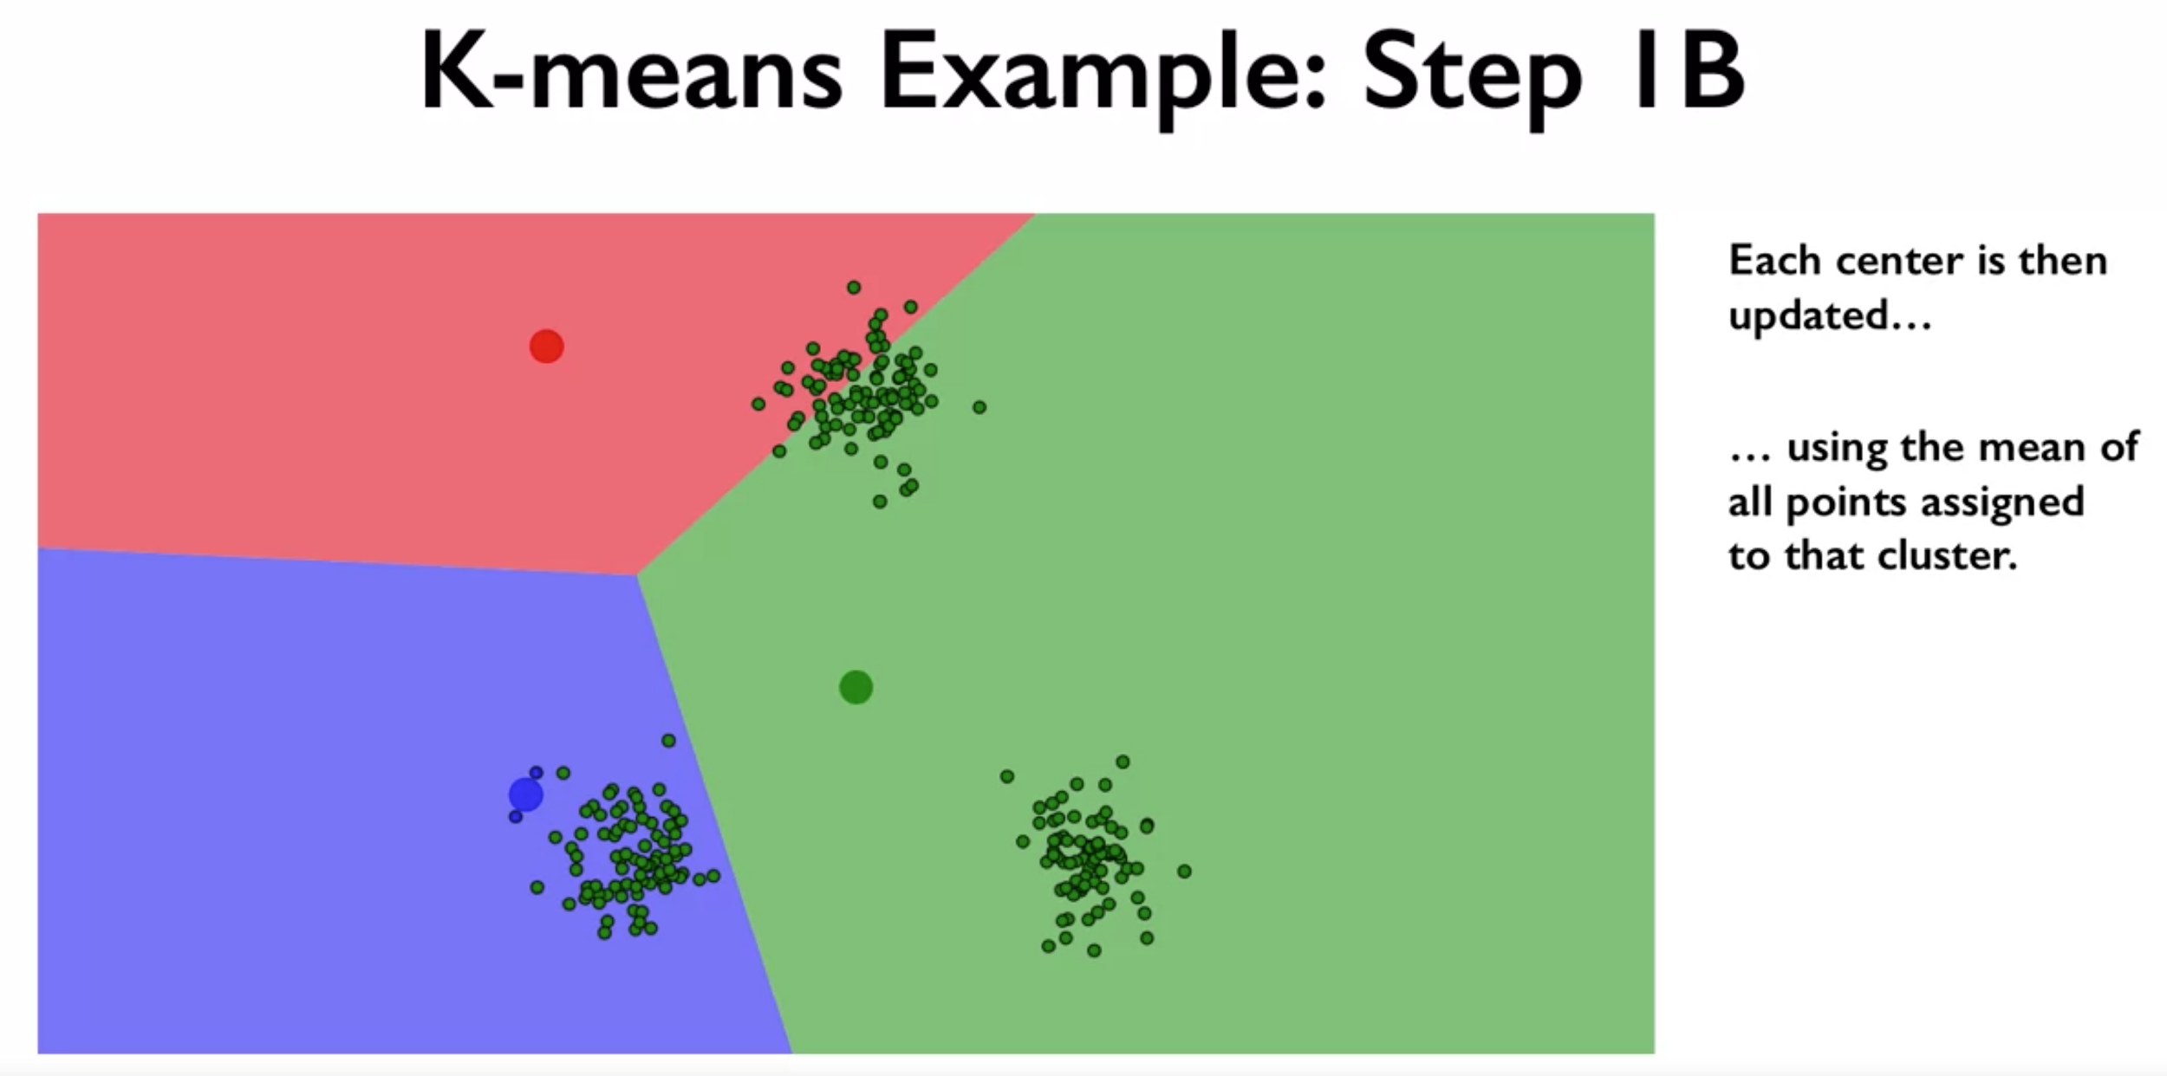

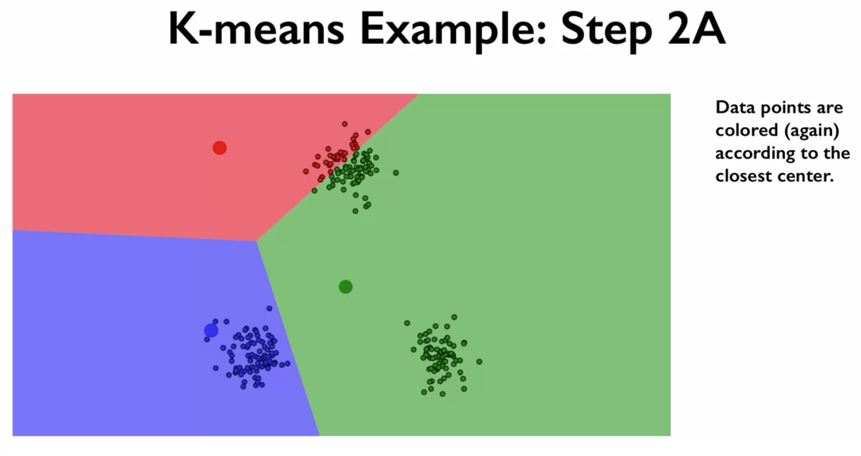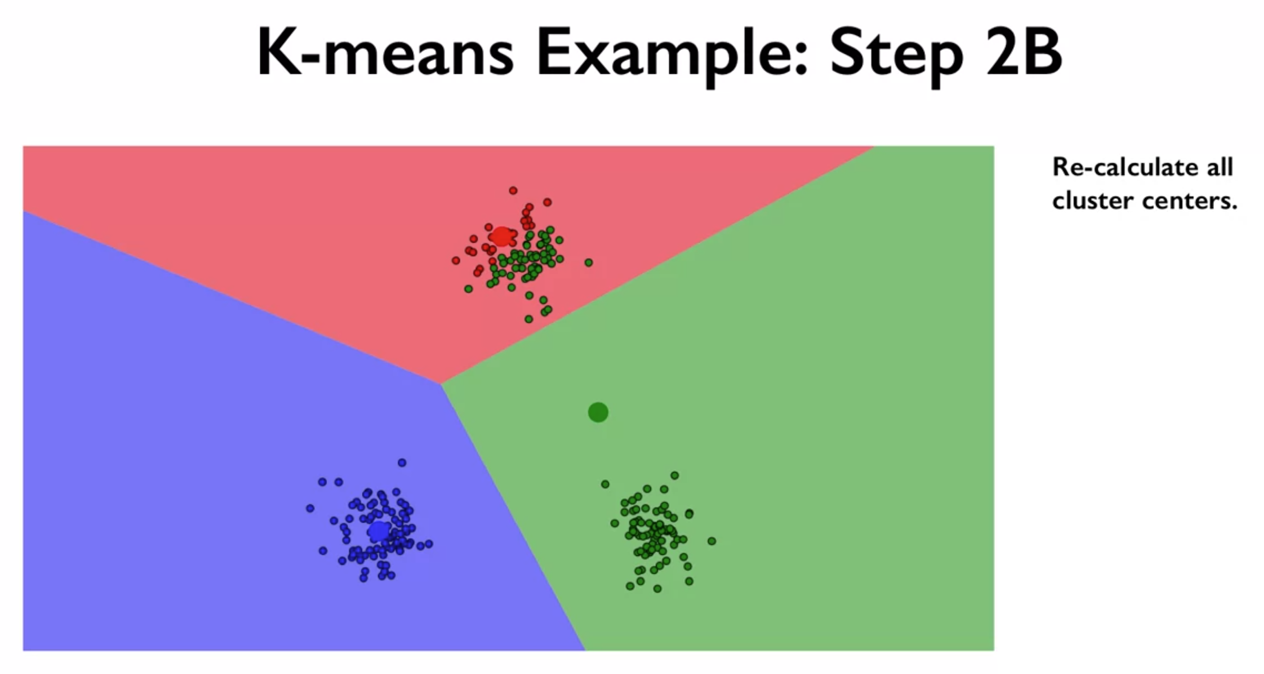

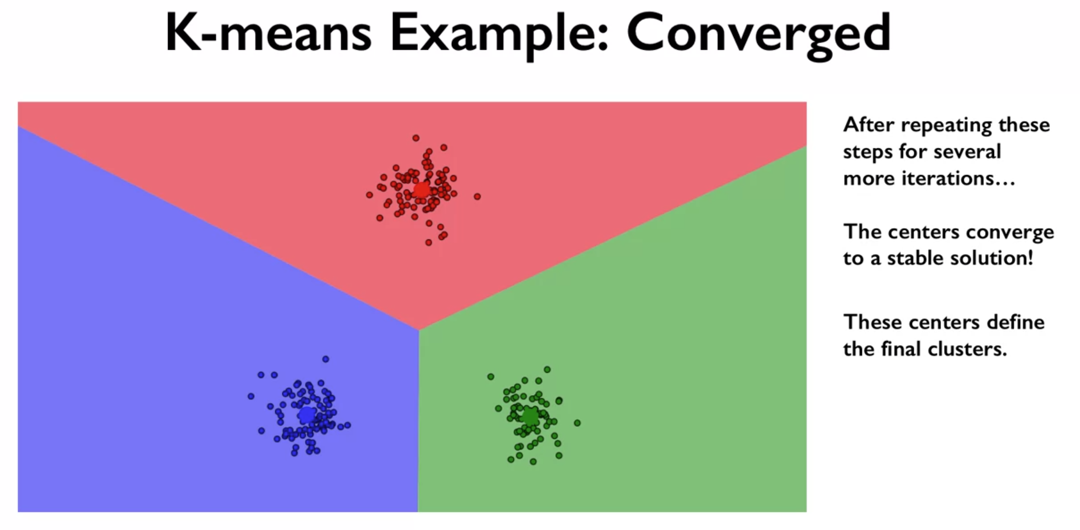

* Somewhat magically, after running this alternating process for a while, coherent clusters do start to form. And the cluster centers and the corresponding cluster assignment for each data point eventually settled down to something stable.

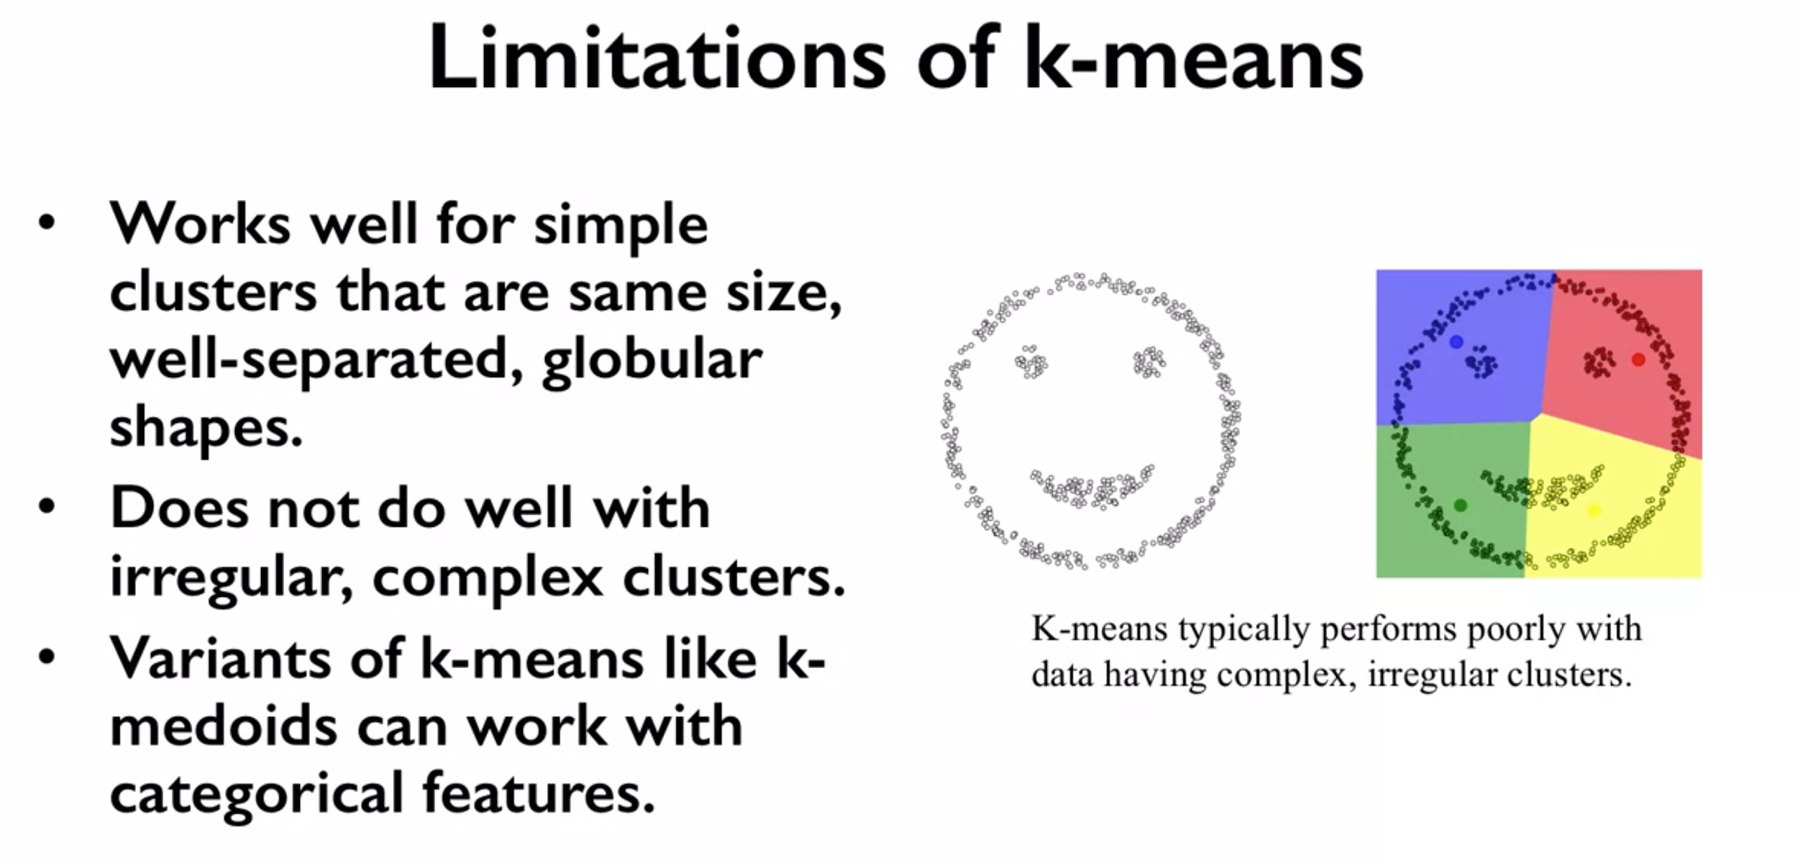

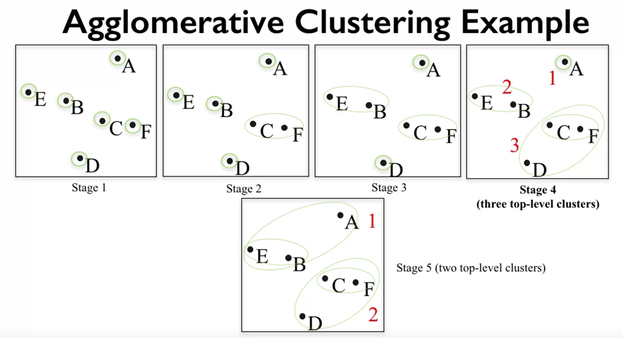

* In Stage 1, each data point is in its own cluster, shown by the circles around the points.
* In Stage 2, the two most similar clusters, which at this stage amounts to defining the closest points are merged.
* And this process is continued, as denoted by the expanding and closed regions that denote each cluster.

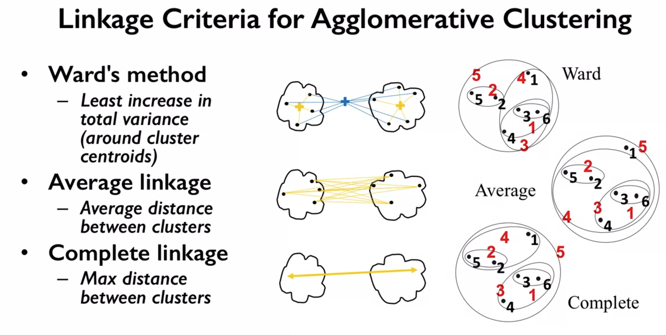

* In general, Ward's method works well on most data sets, and that's our usual method of choice.
* In some cases, if you expect the sizes of the clusters to be very different, for example, that one cluster is much larger than the rest. It's worth trying average and complete linkage criteria as well.

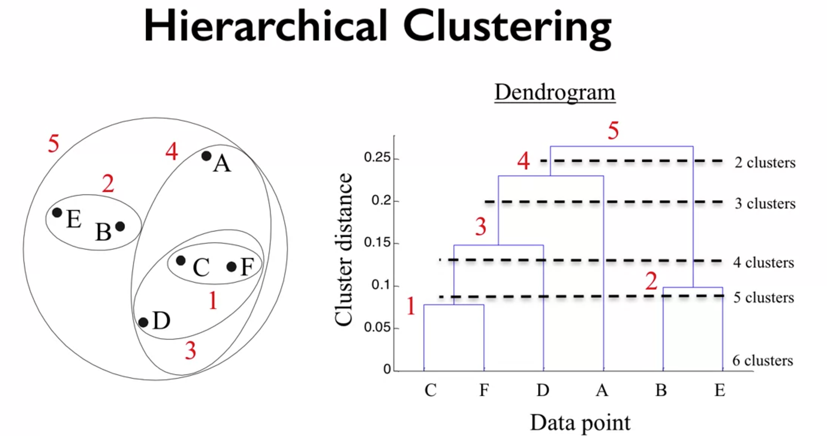

* This property of a dendogram can help us figure out the right number of clusters. In general, we want clusters that have highly similar items within each cluster, but that are far apart from other clusters. For example, we can see that going from three clusters to two happens at a fairly high Y value. Which means the clusters that were merged were a significant distance apart.
* We might want to avoid choosing two clusters and stick with three clusters that don't involve forcing a merge for clusters that have very dissimilar items in them.

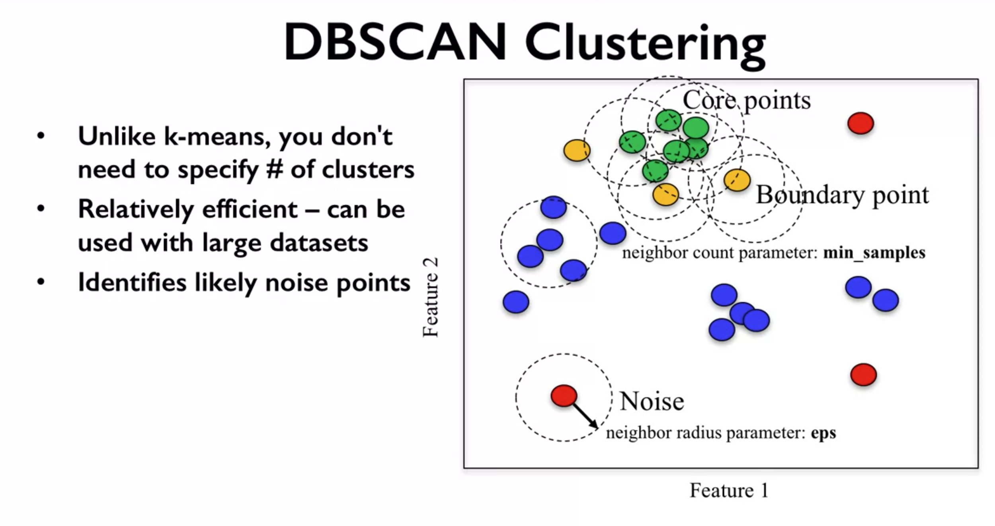

* DBSCAN is an acronym that stands for density-based spatial clustering of applications with noise.
* The main idea behind DBSCAN is that clusters represent areas in the dataspace that are more dense with data points, while being separated by regions that are empty or at least much less densely populated.
* All points that lie in a more dense region are called core samples.
* In addition to points being categorized as core samples, points that don't end up belonging to any cluster are considered as noise. While points that are within a distance of eps units from core points, but not core points themselves, are termed boundary points.

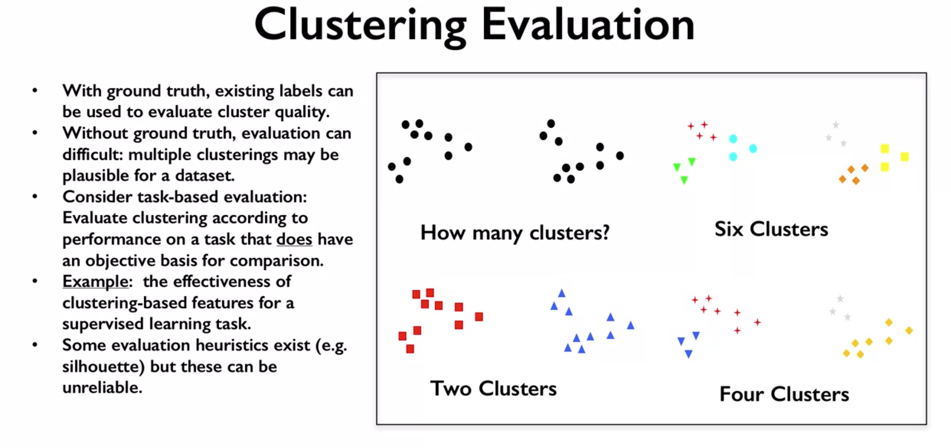

* But there are many cases where labels are not available. In addition, in the case of clustering, for example, there's ambiguity, in a sense that there are typically multiple clusterings that could be plausibly assigned to a given data set.
* And none of them is obviously better than another unless we have some additional criteria. Such as, performance on the specific application task that does have an objective evaluation to use as a basis for comparison.
* Another issue with evaluating clustering algorithms is that it can be hard to automatically interpret or label the meaning of the clusters that are found. And this is still a step that requires human expertise to judge.